**Structure**

* The structure in C is a user-defined data type that can be used to group items of possibly different types into a single type. The **struct keyword**is used to define the structure in the C programming language.
* The items in the structure are called its **member** and they can be of any valid data type.

Structure tag/ Structure Name

Struct Keyword

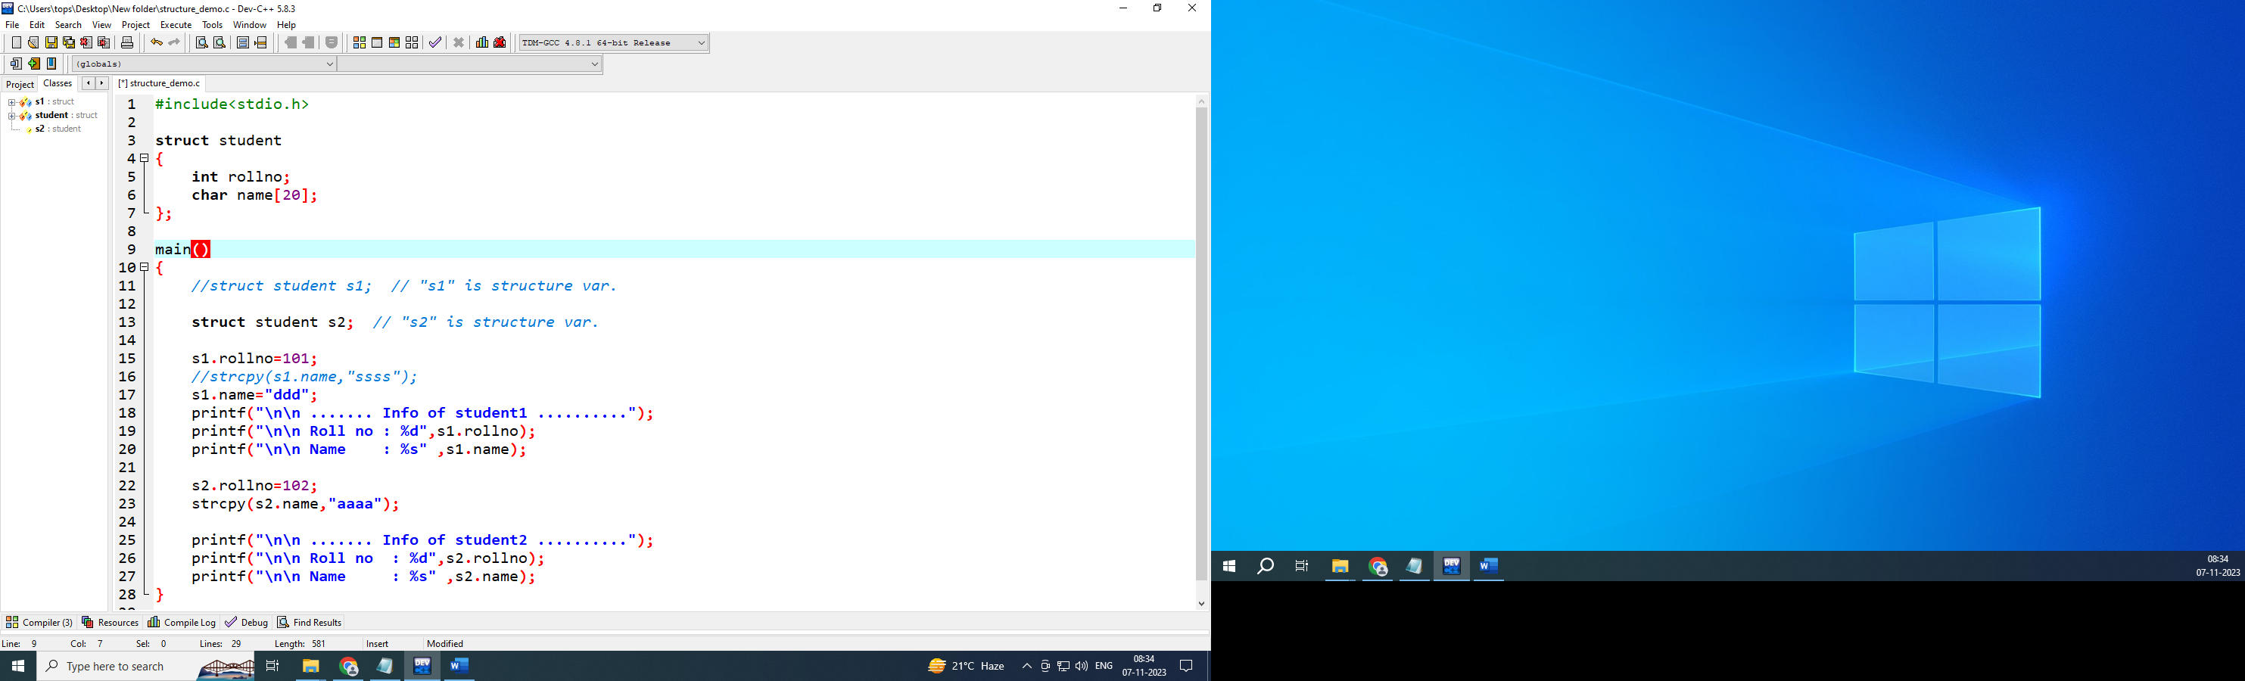

Members or Fields of Structure

**C Structure Declaration**

We have to declare structure in C before using it in our program. In structure declaration, we specify its member variables along with their datatype.

We can use the struct keyword to declare the structure in C using the following syntax:

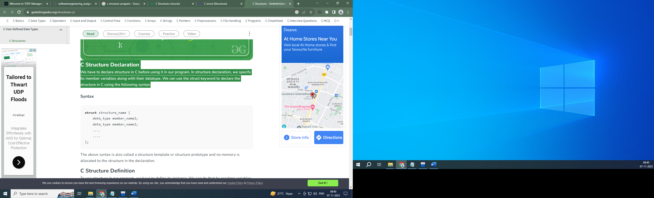

## The above syntax is also called a structure template or structure prototype and no memory is allocated to the structure in the declaration.

## 

## C Structure Definition

To use structure in our program, we have to define its instance. We can do that by creating variables of the structure type. We can define structure variables using two methods:

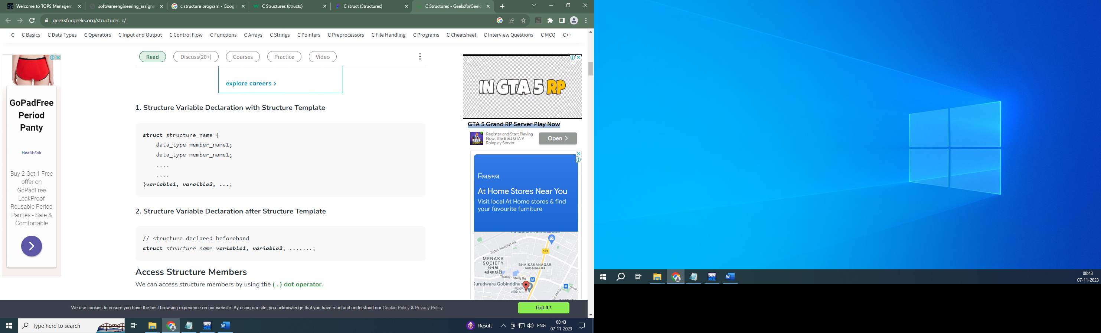

## Access Structure Members

We can access structure members by using the **( . ) dot operator.**

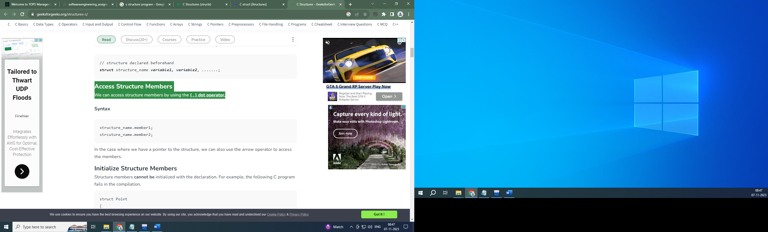

## Initialize Structure Members

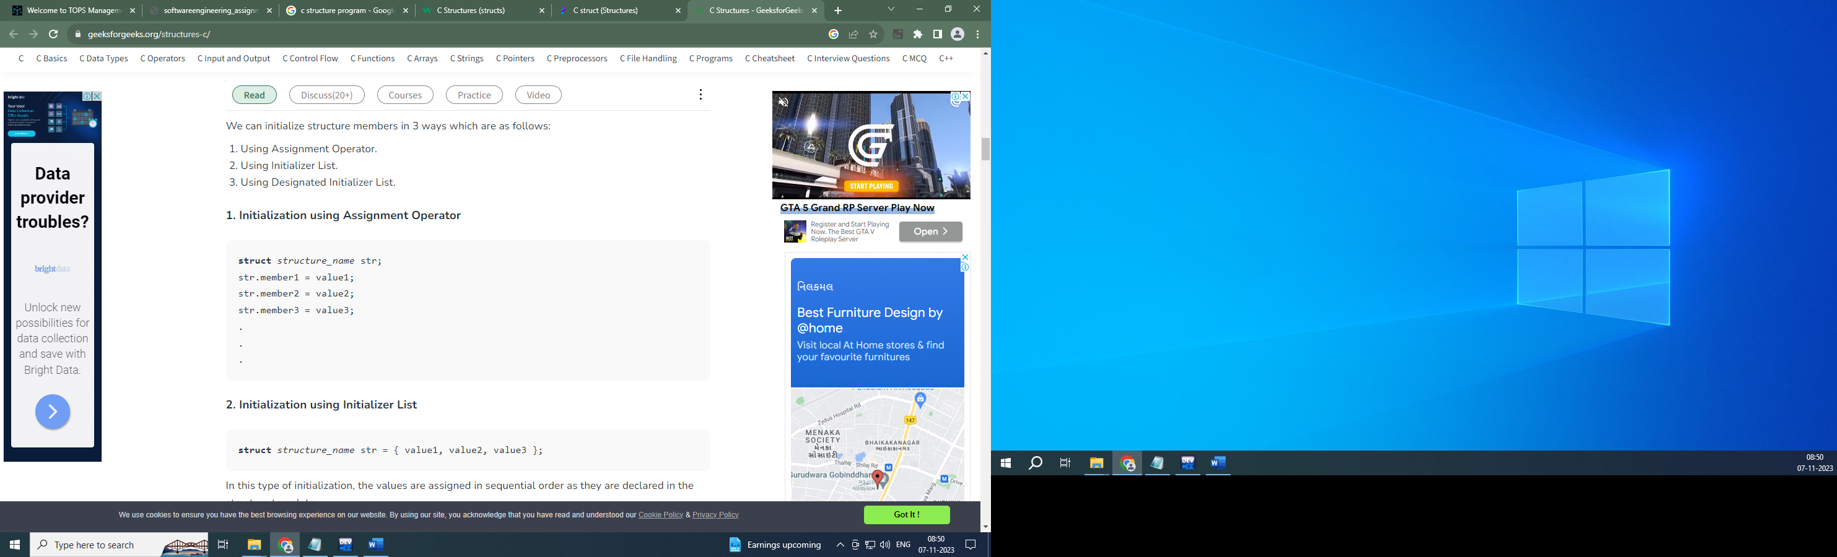

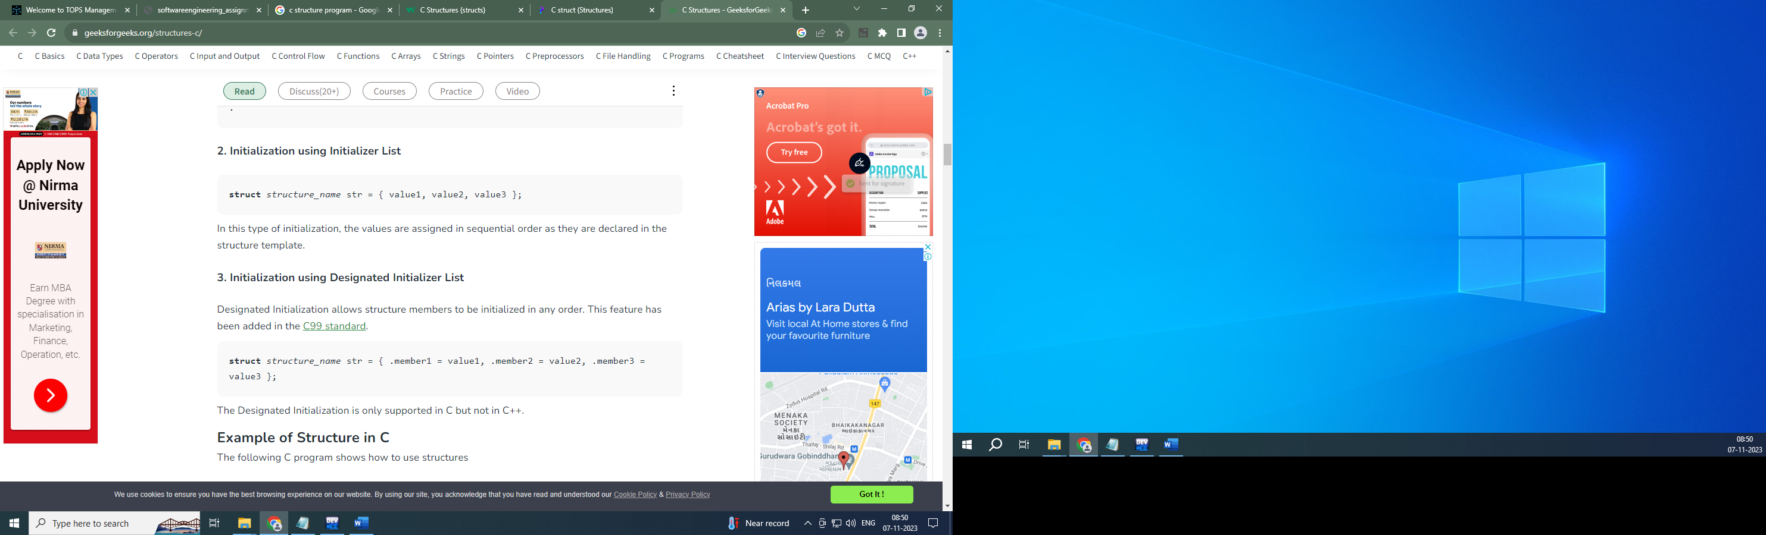

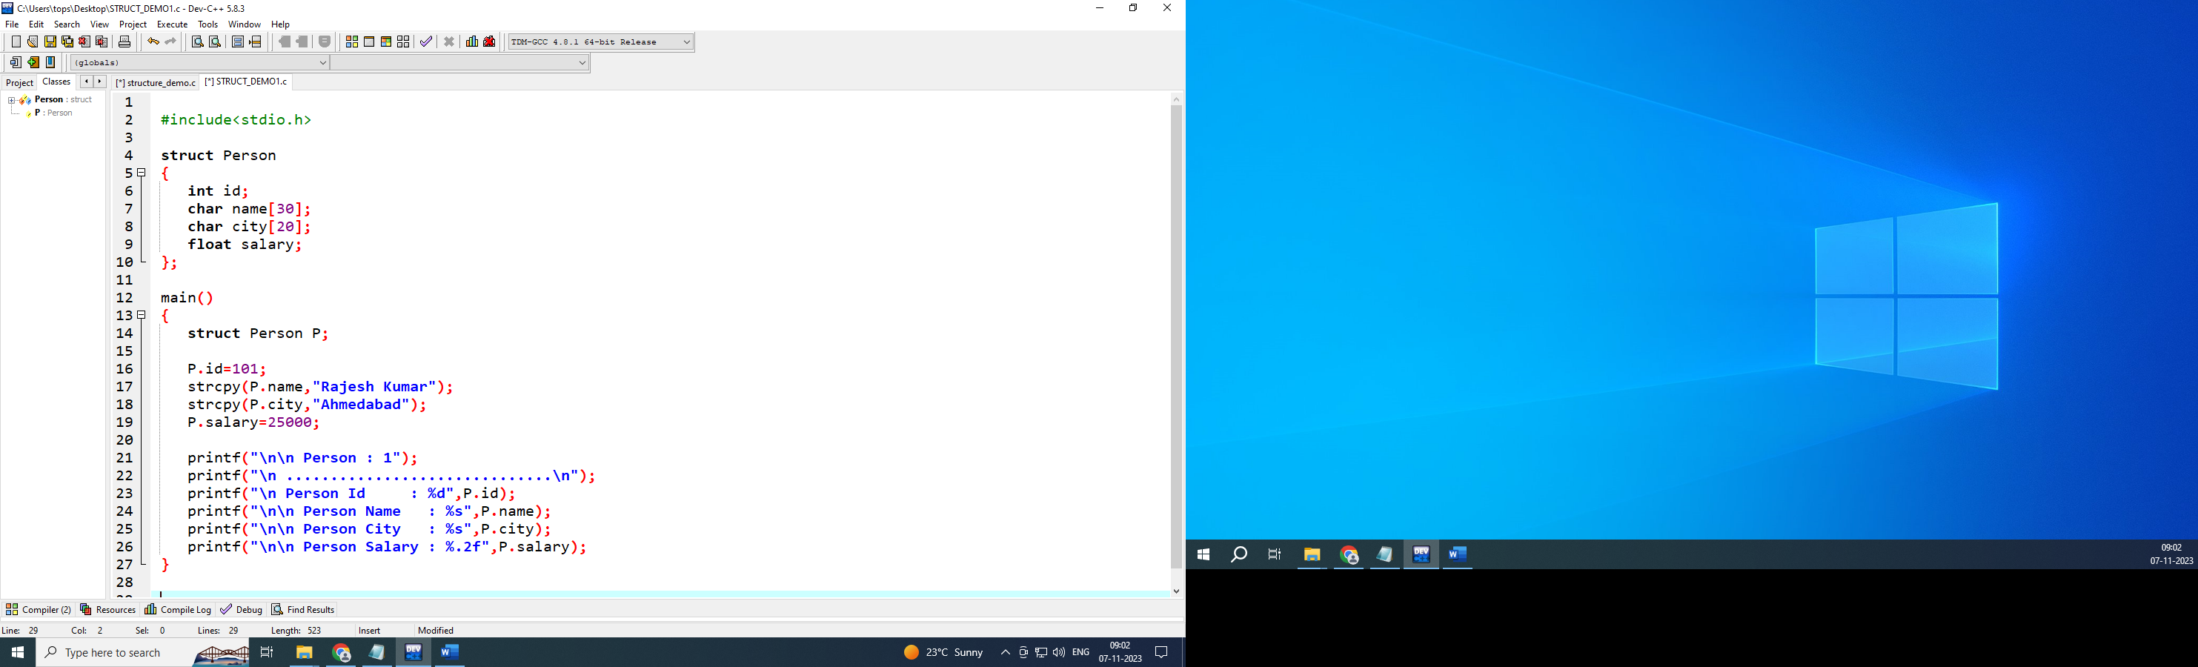

* The**typedef**is a keyword that is used to provide existing data types with a new name. The C typedef keyword is used to redefine the name of already existing data types.
* When names of datatypes become difficult to use in programs, typedef is used with user-defined datatypes, which behave similarly to defining an alias for commands.

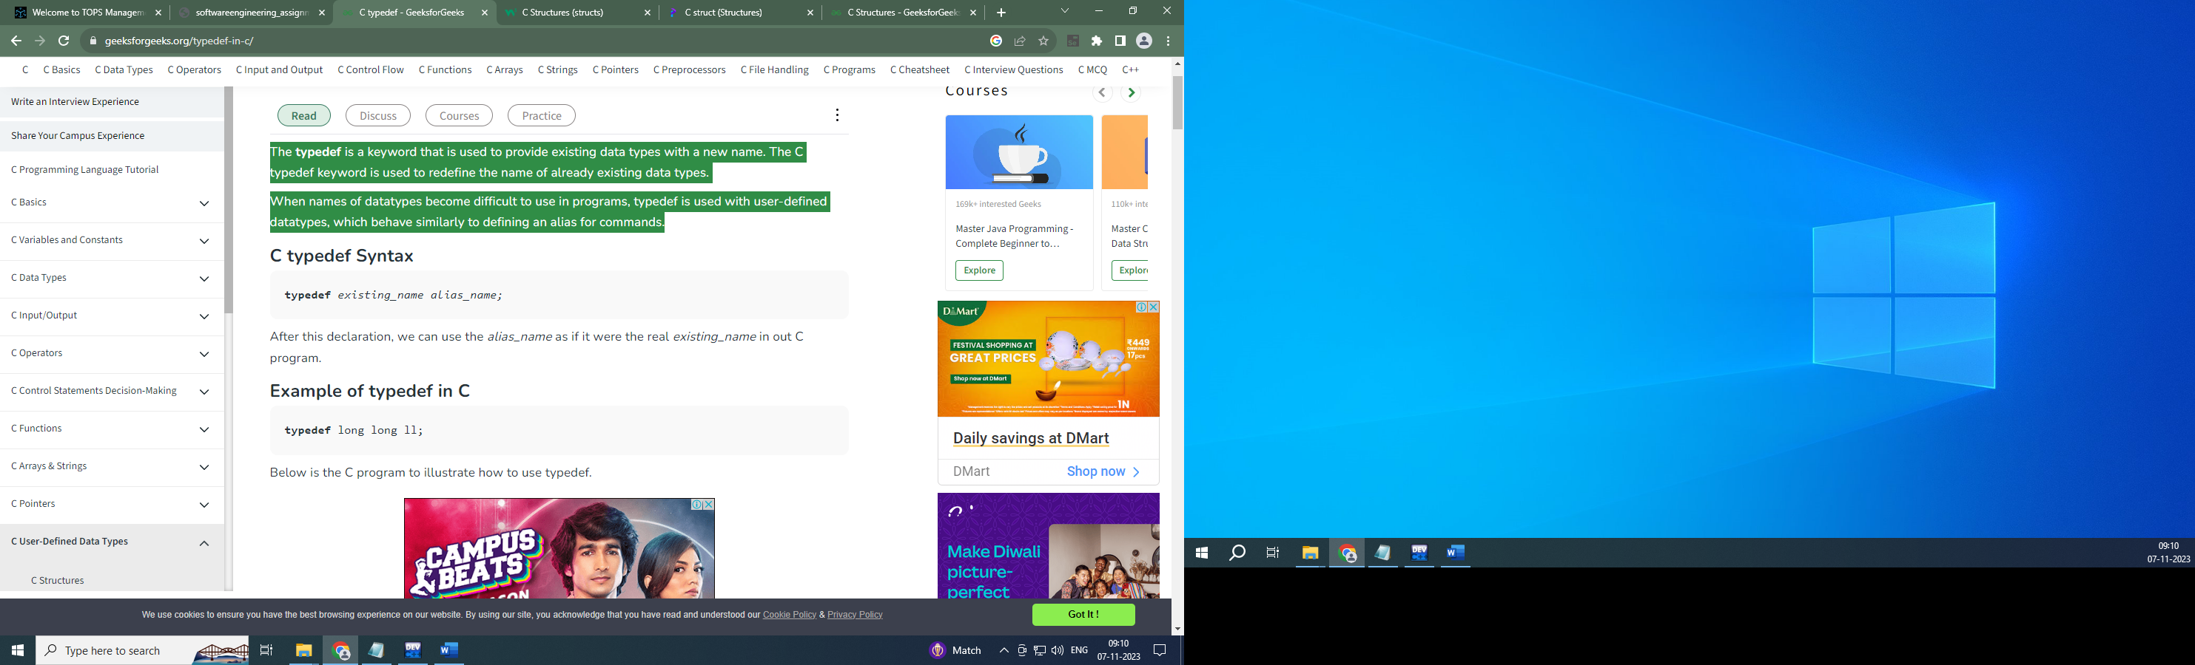

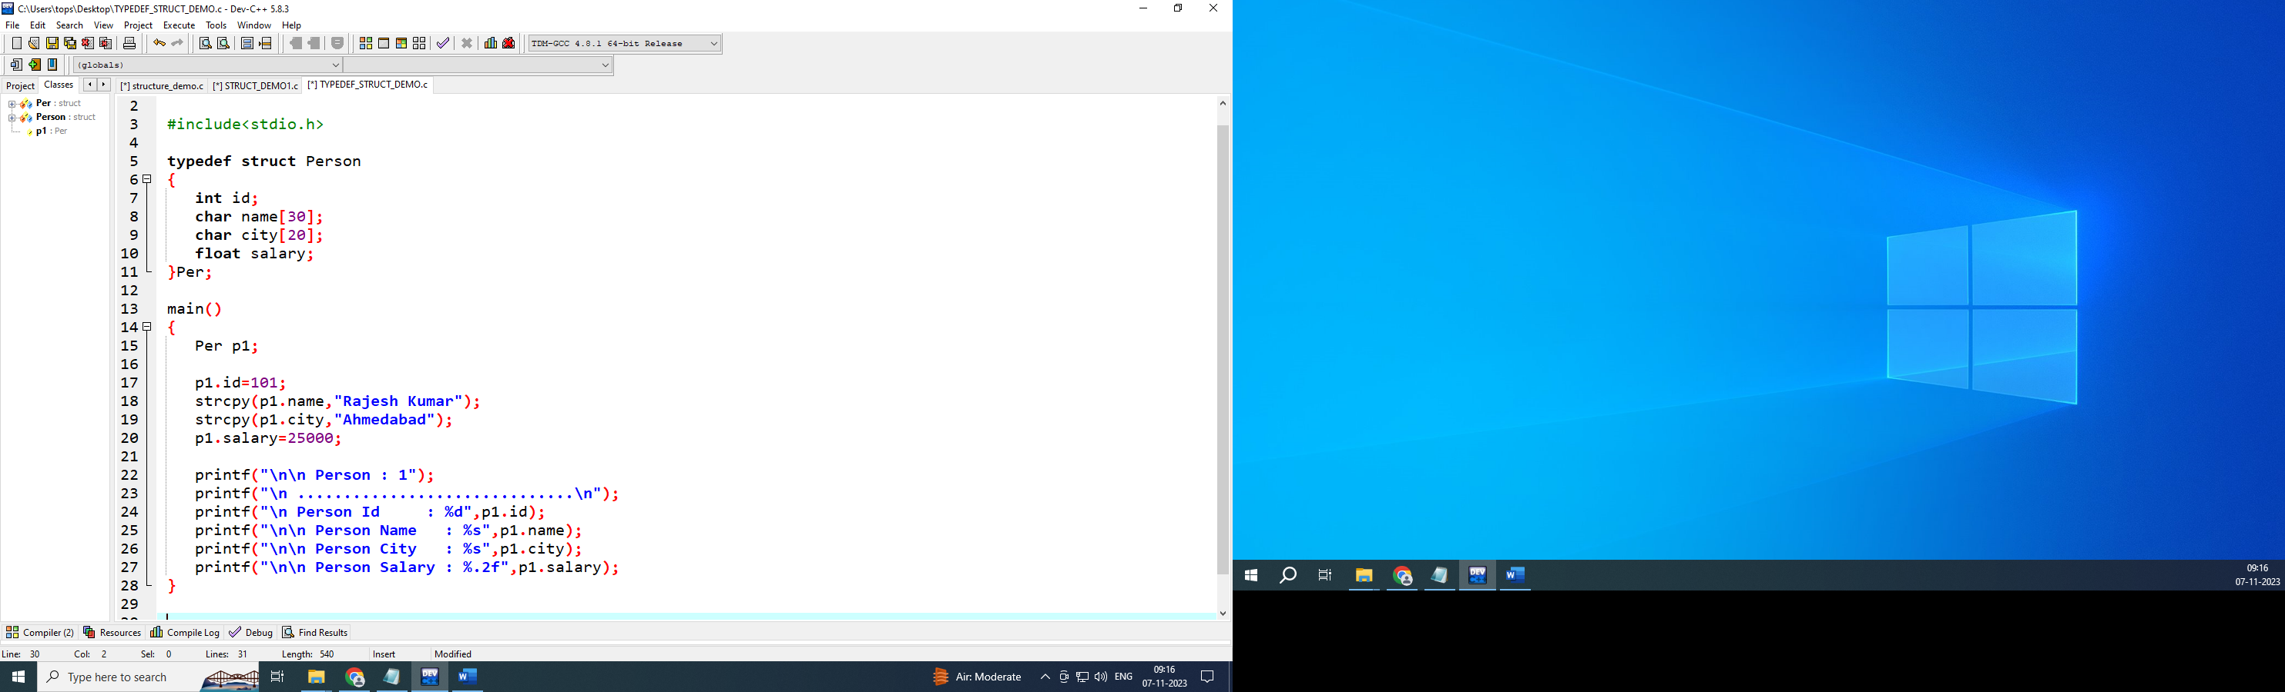

**Note :** typedef is used to create alias for data types.

**Structure Variable Array**

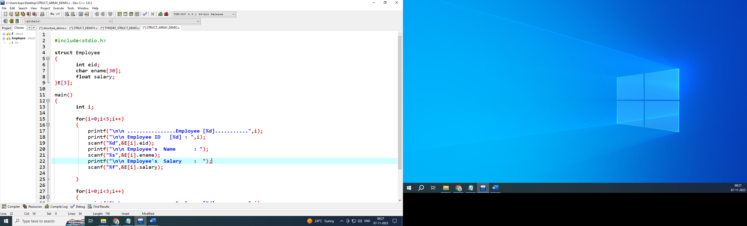

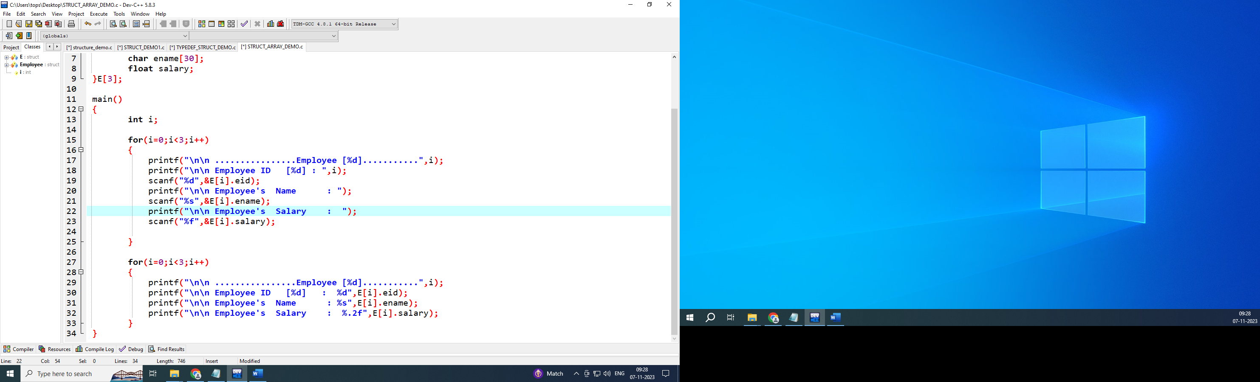

**Nested Structure**

A **nested structure** in C is a structure within structure. One structure can be declared inside another structure in the same way structure members are declared inside a structure.

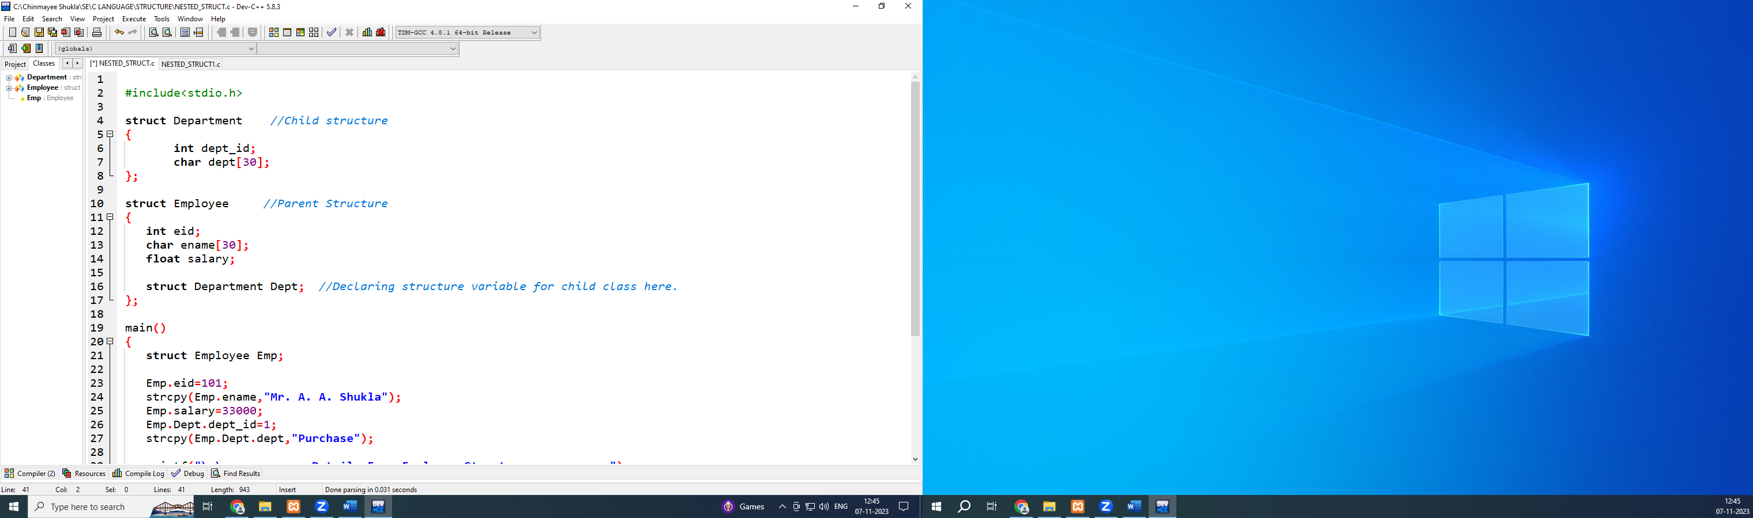

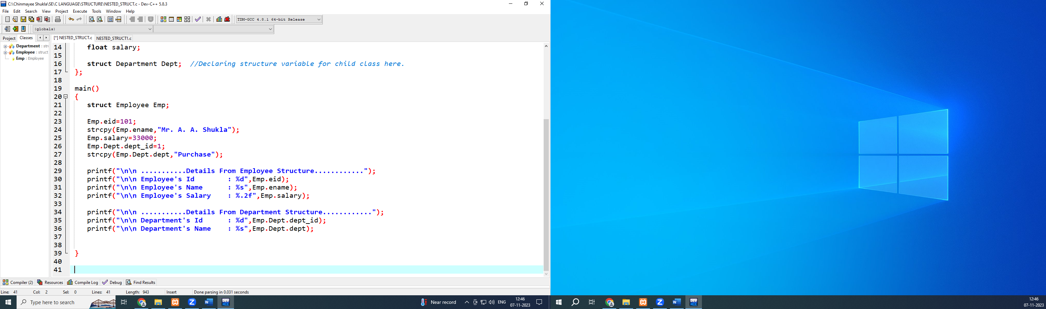

|  |  |
| --- | --- |
|  |  |

**Union**

Union is an user defined datatype in C programming language. It is a collection of variables of different datatypes in the same memory location.

You can define a union with many members, but only one member can contain a value at any given time. Unions provide an efficient way of using the same memory location for multiple-purpose.

|  |  |
| --- | --- |
|  |  |

|  |  |
| --- | --- |
|  |  |
|  |  |

**Pointer**

A **pointer**is a variable that **stores**the **memory address** of another variable as its value. A **pointer variable** **points** to a **data type**(like int) of the same type, and is created with the * operator. The address of the variable you are working with is assigned to the pointer:

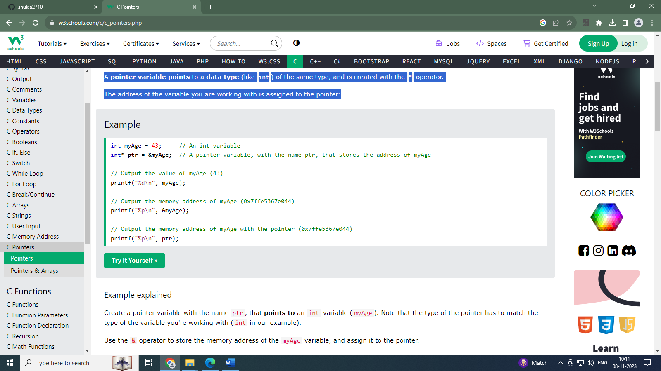

Create a pointer variable with the name ptr, that **points to** an int variable (myAge). Note that the type of the pointer has to match the type of the variable you're working with (int in our example).

Use the & operator to store the memory address of the myAge variable, and assign it to the pointer.

Now, ptr holds the value of myAge's memory address.